|  |
| --- |
| Department of Software Engineering  Mehran University of Engineering and Technology, Jamshoro |

|  |  |  |  |
| --- | --- | --- | --- |
| Course: SW222 – Database Management & Administration | | | |
| Instructor | Ms Shafiya Qadeer | **Practical/Lab No.** | 14 |
| Date | 24-03-2021 | **CLOs** | 3 |
| Signature |  | **Assessment Score** | 2 Marks |

|  |  |
| --- | --- |
| Topic | To become familiar with stored procedures and stored functions. |
| Objectives | * To become familiar with Creating Procedures and Functions |

|  |
| --- |
| Lab Discussion: Theoretical concepts and Procedural steps |

**Stored Procedure:**

A stored procedure is a prepared SQL code that you can save, so the code can be reused over and over again.

So if you have an SQL query that you write over and over again, save it as a stored procedure, and then just call it to execute it.

You can also pass parameters to a stored procedure, so that the stored procedure can act based on the parameter value(s) that is passed.

**Stored Procedure Syntax:**

CREATE PROCEDURE *procedure_name*  
AS  
*sql_statement*  
GO;

Execute a Stored Procedure

EXEC *procedure_name*;

## Demo Database

Below is a selection from the "Customers" table in the Northwind sample database:

|  |  |  |  |  |  |
| --- | --- | --- | --- | --- | --- |
| **CustomerName** | **ContactName** | **Address** | **City** | **PostalCode** | **Country** |
| Alfreds Futterkiste | Maria Anders | Obere Str. 57 | Berlin | 12209 | Germany |
| Ana Trujillo Emparedados y helados | Ana Trujillo | Avda. de la Constitución 2222 | México D.F. | 05021 | Mexico |
| Antonio Moreno Taquería | Antonio Moreno | Mataderos 2312 | México D.F. | 05023 | Mexico |
| Around the Horn | Thomas Hardy | 120 Hanover Sq. | London | WA1 1DP | UK |
| Berglunds snabbköp | Christina Berglund | Berguvsvägen 8 | Luleå | S-958 22 | Sweden |

## Stored Procedure Example:

The following SQL statement creates a stored procedure named "SelectAllCustomers" that selects all records from the "Customers" table:

### Example:

CREATE PROCEDURE SelectAllCustomers  
AS  
SELECT * FROM Customers  
GO;

Execute the stored procedure above as follows:

### Example:

EXEC SelectAllCustomers;

## Stored Procedure With One Parameter

The following SQL statement creates a stored procedure that selects Customers from a particular City from the "Customers" table:

### Example:

CREATE PROCEDURE SelectAllCustomers @City nvarchar(30)  
AS  
SELECT * FROM Customers WHERE City = @City  
GO;

Execute the stored procedure above as follows:

### Example:

EXEC SelectAllCustomers City = "London";

## Stored Procedure With Multiple Parameters

Setting up multiple parameters is very easy. Just list each parameter and the data type separated by a comma as shown below.

The following SQL statement creates a stored procedure that selects Customers from a particular City with a particular PostalCode from the "Customers" table:

### Example:

CREATE PROCEDURE SelectAllCustomers @City nvarchar(30), @PostalCode nvarchar(10)  
AS  
SELECT * FROM Customers WHERE City = @City AND PostalCode = @PostalCode  
GO;

Execute the stored procedure above as follows:

### Example:

EXEC SelectAllCustomers City = "London", PostalCode = "WA1 1DP";

**Stored Function:**

A stored function is a special kind stored program that returns a single value. You use stored functions to encapsulate common formulas or business rules that are reusable among SQL statements or stored programs.

Different from a [stored procedure](http://www.mysqltutorial.org/mysql-stored-procedure-tutorial.aspx), you can use a stored function in SQL statements wherever an expression is used. This helps improve the readability and maintainability of the procedural code.

MySQL stored function syntax

The following illustrates the simplest syntax for creating a new stored function:

|  |
| --- |
|  |

First, you specify the name of the stored function after CREATE FUNCTION  clause.

Second, you list all [parameters](http://www.mysqltutorial.org/stored-procedures-parameters.aspx) of the stored function inside the parentheses. By default, all parameters are the IN parameters. You cannot specify IN , OUT or INOUT modifiers to the parameters.

Third, you must specify the data type of the return value in the RETURNS statement. It can be any valid [MySQL data types](http://www.mysqltutorial.org/mysql-data-types.aspx).

Fourth, for the same input parameters, if the stored function returns the same result, it is considered deterministic; otherwise, the stored function is not deterministic. You have to decide whether a stored function is deterministic or not. If you declare it incorrectly, the stored function may produce an unexpected result, or the available optimization is not used which degrades the performance.

Fifth, you write the code in the body of the stored function. It can be a single statement or a compound statement. Inside the body section, you have to specify at least one RETURN statement. The RETURNstatement returns a value to the caller. Whenever the RETURN statement is reached, the stored function’s execution is terminated immediately.

MySQL stored function example

Let’s take a look at an example of using the stored function. We will use the customers table in the [sample database](http://www.mysqltutorial.org/mysql-sample-database.aspx) for the demonstration.

The following example is a function that returns the level of a customer based on credit limit. We use the [IF statement](http://www.mysqltutorial.org/mysql-if-statement/) to determine the credit limit.

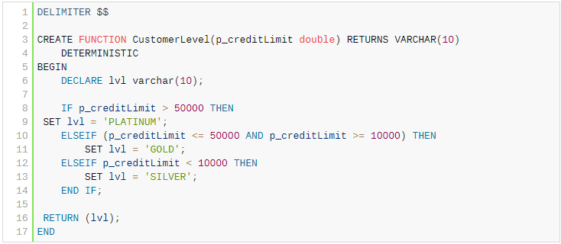



Now, we can call the CustomerLevel() in a [SELECT](http://www.mysqltutorial.org/mysql-select-statement-query-data.aspx) statement as follows:

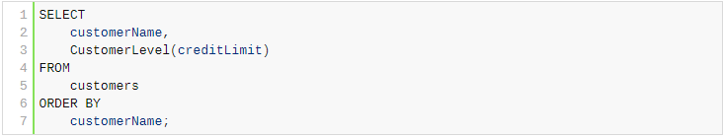

We also rewrite the  GetCustomerLevel() stored procedure that we developed in the [MySQL IF statement](http://www.mysqltutorial.org/mysql-if-statement/) tutorial as follows:

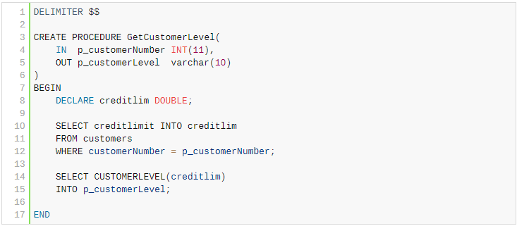

|  |
| --- |
|  |

As you can see, the  GetCustomerLevel() stored procedure is much more readable when using the  CustomerLevel() stored function.

Notice that a stored function returns a single value only. If you include a SELECT statement without the INTO clause, you will get an error.

In addition, if a stored function contains SQL statements, you should not use it inside other SQL statements; otherwise, the stored function will slow down the speed of the query.

In this tutorial, you have learned how to create a stored function to encapsulate the common formula or business rules.

|  |
| --- |
| Lab Tasks |

1. Run the examples given above.
2. Differentiate stored procedures and stored functions.
3. Create your Stored procedure and function using tables of your dbs.